CDSC-2023-0001
2x2
Picture

COLLEGE OF DENTISTRY: COMELEC
APPLICATION FOR CANDIDACY
STUDENT COUNCIL ELECTOION 2023

Name: ____________________________________Age: ___ Student Number: _____________
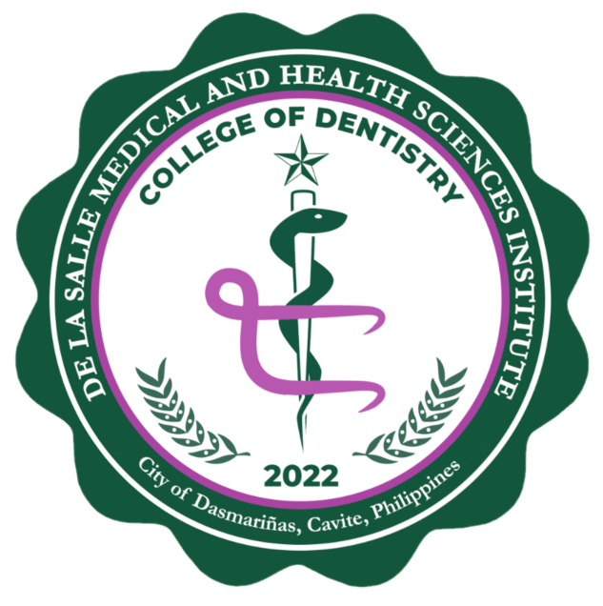
Surname First Name M.I.

Course/Section: ________ Contact Number: _____________________ Gender: ____________
Institutional Email Address:________________________________
Home Address: ________________________________________________________________
Parent/Guardian: ________________________________ Contact Details: _________________
Position Applied For:
( ) Student Council: _________________________
( ) ISC Representative
Political Party Affiliation:
( ) Independent ( ) _____________________
Political Party

Candidacy Name: ___________________________
WILL APPEAR IN THE BALLOT
I further declare the following:
- I am bonafide student of De La Salle Medical and Health Sciences Institute-College of Dentistry.
- If elected as an officer of the Student Council/ ISC Representative, I will not run for any elective or appointive major position in the institute-based organizations during by incumbency.
- I fully understand the task expected of me in the position I am applying for.

Signed on this ____ day of _____________ 20__.

Noted: Arvin B. Laguna, DDM, PhD, FICD ______________________
Student Council / COMELEC Adviser Applicant
(Signature over Printed Name) (Signature over Printed Name)

NOTE: Kindly attach a copy of COR to this form upon submission in the College of Dentistry Office

